The Mendota Mdewakanton Dakota Tribal Community will be Honoring Our Ancestors Saturday Feb 11, 2023. Ceremony will be at the Fort Snelling and on zoom and the DuPuis House.
We will meet even if it is very cold. Consider the people back in 1862 who were forced to brave the cold. Our Dakota ancestors had to walk 500 miles. With just a blanket, not enough food, or shelter.
We will light the sacred fire at 12:00, ceremony is at 1:00. Potluck to follow at the DuPuis House or Sibley Site 1351 Sibley Memorial Hwy Mendota MN 55150.
Lon, Joseph, will light the fire, Tommy, Steve and Joy will assist.
On December 26, 1862, the U.S. military lynched 38 of our Dakota patriots in the largest mass execution in United States history. On November 7, 1862, a group of about 1,700 Dakota, primarily women and children, were forcibly marched from the Lower Sioux Agency to a concentration camp at Fort Snelling.
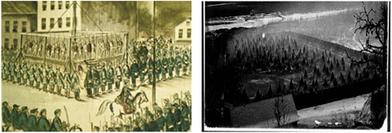
Saturday February 11, 2023.
Fort Snelling State Park. The park entrance is off Highway 5 at Post Road near the Minneapolis/St. Paul International Airport.
Drive down into the park, go inside the building to get your free pass at the entrance building. Thank You to the DNR for their help each year.
If you need more information, please call the Mendota Mdewakanton Dakota Community office 651-452-4141. Dress warm, the ceremony is outside, women should wear skirts, pants under their skirt to keep warm.
Please bring some tobacco and sage.
Pidamaya from the Mendota Mdewakanton Dakota Community!
Sharon Lennartson Tribal Chairwoman, Steve Renville Vice Chairman,
Joe Lennartson Treasurer, Danielle Ross Secretary, Greg Strandmark Historian.

