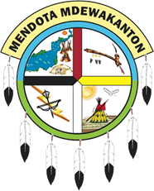

MISSION STATEMENT

Mission of the Mendota Mdewakanton Dakota Community:

“To preserve, protect, and promote the Dakota culture for future generations.”
In 2002, the MMDC membership participated in a comprehensive strategic planning session that resulted in the development of seven (7) long-range goals striving to:
1. Maintain and keep a tribal office in Mendota.
2. Obtain federal recognition.
3. Acquire a land base.
4. Teach community members and others the Dakota language.
5. Develop self-sufficiency through in-house business.
6. Promote a better understanding between the Native American community and the general public.
7. Promote and support the preservation of the Dakota culture, including protecting sites of cultural significance to the Dakota people.

