The Secrets of the Medicine Wheel
Advanced tickets are strongly encouraged as this will be a sold out event

Jackie ‘Red Woman’ Lindow  This is a teaching of the ancient tribal stories and legends of the Medicine Wheel and their sacred secrets, which affect your everyday life.  Jackie ‘Red Woman’ is a world renowned artist, storyteller, tribal elder and grandmother. Her story has aired on over 1000 radio stations worldwide.  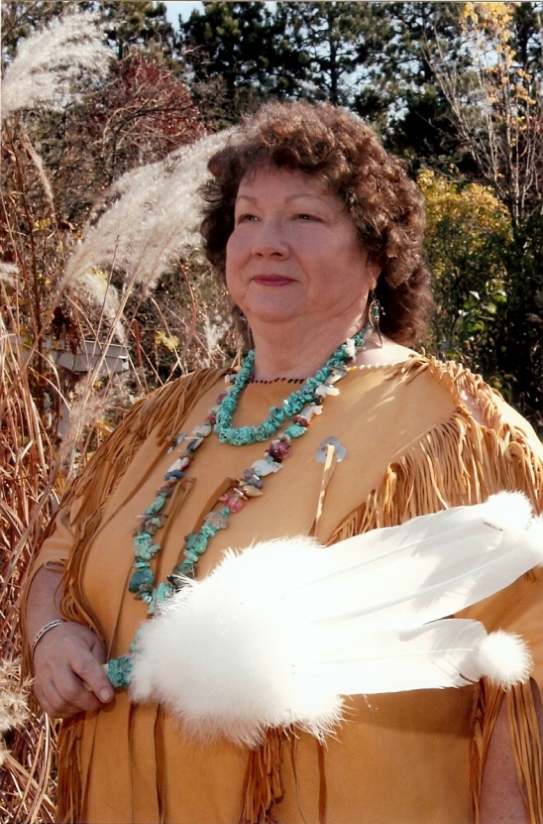 | Music performance by  Michael Monroe  Michael Monroe lives in his log cabin and records his music on the North Shore of Lake Superior in his solar powered MisTree Studio. From vinyl to digital, performing his original acoustic folk, reggae and jazz, he blends rich vocals, guitars, and bamboo and crystal flutes together... recycling his award winning music "live" using looping technology that's powered by creativity.  He performs on Seaton Acoustic Guitars made on the Gunflint Trail and recycled from rare North Shore woods including 200 year old salvaged wood from the bottom of Lake Superior. The guitars have names such as Snow Leopard, Soibahn and Flamenca Del Rosa.  Listen to Michael  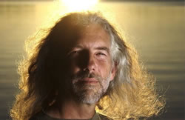  Read more about Michael’s biography

Saturday January 21 at 1:00pm
Advanced tickets are a $20 Spiritual Gift
Contact Gene Montanez at reikibearspirit@gmail.com for ticket information Unity Christ Church, 4000 Golden Valley Road, Golden Valley, MN 55422
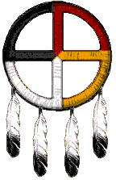

The Healing

Medicine Wheel

Jackie ‘Red Woman’ Lindow wishes to take this opportunity to honor those Elders who have paved the way for the Wellbriety Movement. Their efforts and dedication to Native American sobriety and wellness have made this movement possible. It is with a humble heart that she has been given permission by tribal elders to speak of the ancient Secrets of the Medicine Wheel.
Bill Iron Moccasin (Lakota), Bill and Carol Iron Moccasin (Lakota), Harold and Wanda Frogg (Ojibwe), Ozzie Williamson (Blackfeet), Horace and Andrea Axtell (Nez Perce), Henrietta Mann (Northern Cheyenne), and Marie Randall (Lakota).
In Native American spirituality, the Medicine Wheel is also referred to as the sacred hoop that represents the sacred circle of life, in all four directions, with harmony and connections to spirit, which is considered a major symbol of peaceful interaction among all living beings on Earth.
The medicine wheel also represents the balance of not only our surroundings but our mental, physical, spiritual and emotional wellbeing. The wheel also represents our life’s never ending cycle of birth, death and rebirth. The teachings of the Medicine Wheel tell us to live a good life, meaning we must be present in the Now, and actively engaged in consciousness for it to work.
A number of stone Medicine Wheels are scattered across the plains of Alberta and the northern United States. Some are extremely large with a diameter greater than 12 meters across, that document more than 7,000 years of their history in this area.
Despite their physical existence, there is a lot of mystery that surrounds the Medicine Wheel, as no written record to their purpose has been found. Jackie’s visions, prayers, and crying to the Grandfathers and Grandmothers are why she is sharing the secrets of the Sacred Medicine Wheel with you.
Jackie ‘Red Woman’ was born into the Little River Band of Ottawa Indians in March of 1949. The Ottawa originally came from Manistee, Michigan area, but after a large fire wiped out thousands of acres and much of the Ottawa village many years ago, Jackie’s Grandmother, Christina Thomas, and her aunt, Louise Thomas, moved to northern Wisconsin. Of the 700 Ottawa tribal members in Wisconsin, most of them can be traced back to Jackie’s Grandmother or aunt. As a child, her Grandmother taught her to express and celebrate her cultural origins. Jackie’s gift for storytelling was inherited from her mother. “Stories of our past experiences can make the happiness from the past continue.”

Jackie has completed extensive studies in Native American theater, art and spiritually within the Milwaukee area. She shares this knowledge, as well as powerful life experiences, with children and adults through the making and interpretation of traditional dream catchers and telling of traditional oral traditions.
When creator aligned my spirit with my hands and eyes, I became a master artist. As a native, I understand the spirit of a people can be broken but, with the honest help of one another, we create conditions that can bring healing.
A vision of our people healing in their minds, bodies and spirits according to the law of the harvest was given to me, that I gladly share with those who wish to hear.
Jackie is also a ‘Firestarter’ which is a life commitment, to invest in the continued addictions-recovery, of Native American Indian families. As a recovering alcoholic, Jackie’s words and beliefs are cited in Alcohol Problems in Native America, and The Red Road to Wellbriety in The Native American Way.

In 2004, Jackie was featured in ‘Passages’, a broadcast by Dennis Benson, an award winning radio program featuring inspirational passage points from people’s lives.
The program was broadcasted over 1000 radio and Armed Forces stations all over the world, for one year.
Jackie tells of her life and the hardships of being accepted because of the light color of her skin and red hair, while her family and Grandmother were rejected for being Native American.
This compelling, heart filled expression of sadness and hope is clearly conveyed as a tribute to her Grandmothers legacy and Native American survival.
Featured music on the CD includes artists such as Dolly Parton, Emmy Lou Harris, Bob Dylan, Whitney Houston, and Tracy Chapman.
At the conclusion of the teachings a copy of this CD is a free gift from Jackie to you!

