Honoring Our Ancestors Saturday Feb 9, 2019. We will meet even if it is very cold. Consider the people back in 1862 who were forced to walk with no food, warm clothes, and no real shelters. Many were woman and children, the sick and elderly. In Addison to the above, they had lost everything they knew and loved. EVERYTHING!
On December 26, 1862, the U.S. military lynched 38 of our Dakota patriots in the largest mass execution in United States History. On November 7, 1862, a group of about 1,700 Dakota, primarily women and children, were forcibly marched from the Lower Sioux Agency to a concentration camp at Fort Snelling.
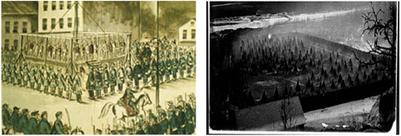
Saturday February 9, 2019
We will light the sacred fire at 10:00am. Ceremony is at 11:00pm.
Where
Fort Snelling State Park.
The park entrance is off Highway 5 at Post Road near the Minneapolis / St. Paul International Airport.
Drive down into the park, go inside the building to get your free pass, which is this flyer, or print it now. Mendota will have flyers at the entrance building too. Thank You to the DNR for their help each year.
Please bring a dish to share for the potluck from 12:30ish to 3:00ish. Potluck or feast will be at the DuPuis House, also called the Sibley Site.
1357 Sibley Memorial Hwy Mendota, MN 55150 across from Lucky's 13.
If you need more information, please call the Mendota Mdewakanton Dakota Tribal Community office 651-452-4141. Dress warm, the ceremony is outside women should wear skirts pants underneath to keep warm. Please bring some tobacco. Mendota can provide doughnuts. Steve will provide coffee from JS Bean Factory. Cell: 651 699 7788, Fax: 651 699 7788, E-mail: steve@juststevesbeanfactory.com, Address: 1518 Randolph Ave St. Paul, MN 55105.
Pidamaya ye
Sponsored by the Mendota Mdewakanton Dakota Tribal Council and its members.
Sharon Lennartson Tribal Chairwoman

