**BDOTE DAKOTA WATER SUMMIT**

**Sunday, April 17, 2016**

**12:30 to 3 pm**

**Fort Snelling State Park Visitor Center at Bdote, the meeting of the Mississippi and Minnesota rivers**

Worldwide we are at crisis level for drinkable water, even here in the state named Mi-ni, water.

The summit will focus on bringing together spiritual and environmental understandings in order to protect the water commons.

Locally we want to take action on a new threat to Coldwater Springs (Mi-ni Owe Sni), a sacred and historic site, and identify steps to preserve this 10,000-year old spring. Coldwater is the last major natural spring in Hennepin County.

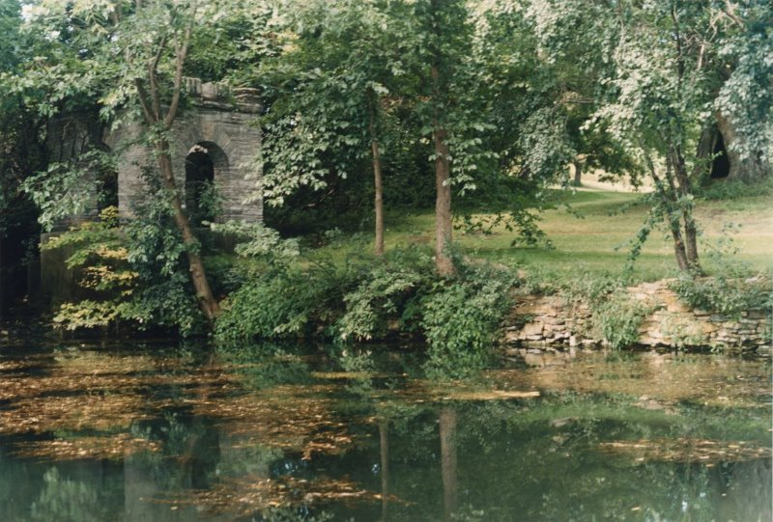

Photo: Friends of Coldwater

We will begin with a traditional Dakota water ceremony.

The summit will convene tribal leaders; water, environmental and legal advocates; youth; and spiritual and civic allies to protect Coldwater Springs.

Directions: From St. Paul exit Hwy 5 at Post Road. From Minneapolis take the airport exit off Hwy 55 onto Hwy 5 and exit at Post Road. Turn east into Fort Snelling State Park. The Visitor Center is 2-miles from the park entrance, drive to the end of the road near the Bdote, the confluence of the Mississippi and Minnesota rivers. No entrance fee, just show this flyer or get a copy of this flyer in the park office.

Hosted by the Mendota Mdewakanton Dakota Tribal Community. Convenor Sharon Lennartson, Chairwoman MMDTC. Information: <http://mendotadakota.org> or 612-913-1903.

Free. Everyone welcome.

Owasin cantewasteya upo! (Come with a good heart!)