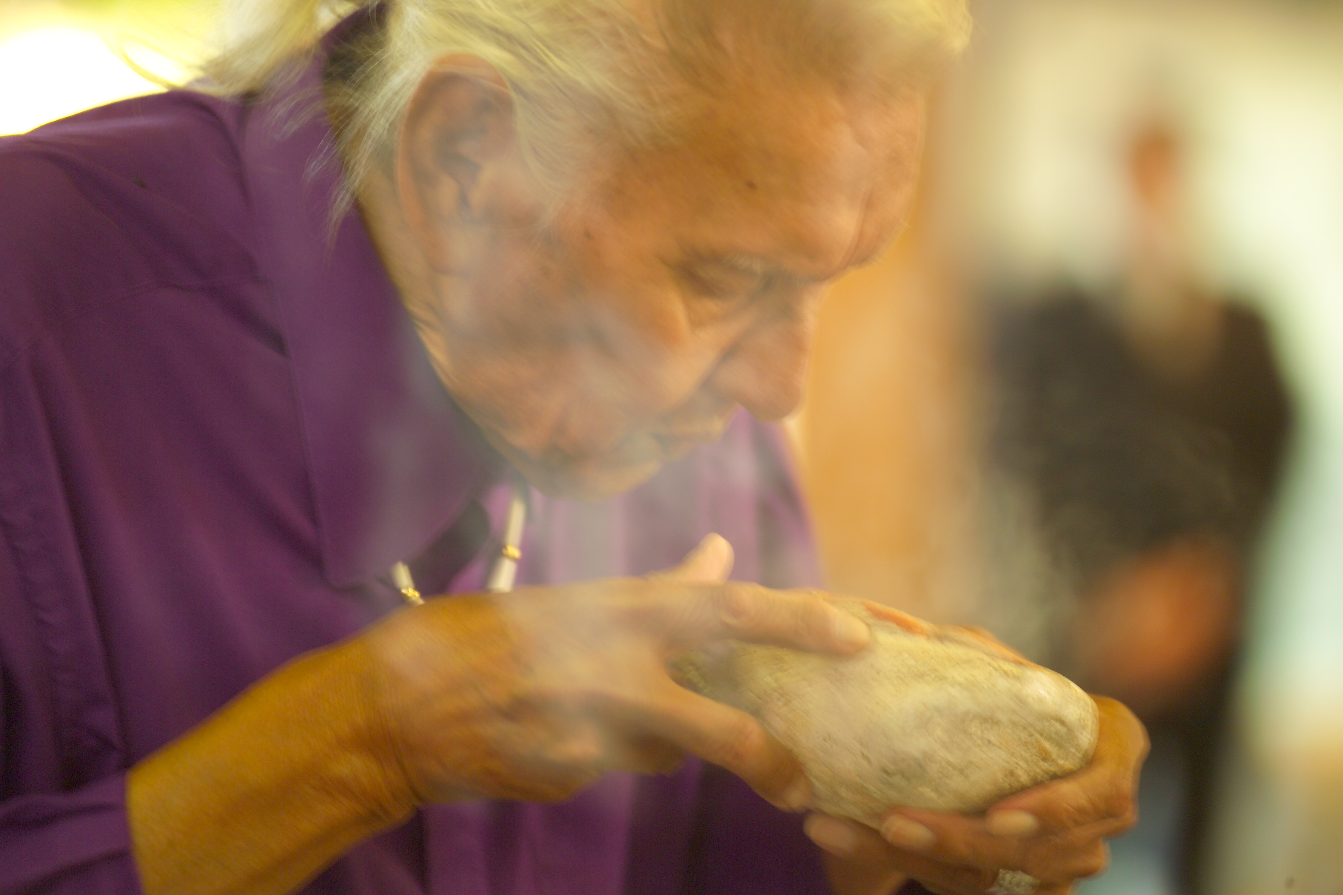

Memorial In Honor of Garrett “Kenny” Wilson
September 16, 1931-December 23, 2010

Son of Obed Wopeton Hanska Mazakaga Wilson and Rose Wahca Red Day.
Long Hollow Community Center
Sisseton, SD
June 25th at 1:00

Feast following the memorial. Please bring a dish to share.
For more information contact: Lynne (612) 588-1426 or
Clifford Canku 1 (605) 698-4023

