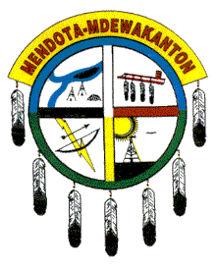
The 9th Annual
Welcome Home
Traditional
Public Welcome!
Public Welcome!
POW-WOW

August 8, 9, 10, 2008
St. Peter’s Church Grounds in Mendota, Minnesota

Emcee: | Mitch Walking Elk
Arena Director: | Windy Downwind
Host Drum:  Co Host: | Anpetu Duta (Red Day)  Waukaazo-Day-Egun
Honorary Head Dancer: | Marie Nordin
Men’s Head Dancer: | John Oakgrove
Women’s Head Dancer: | Good Thunder Woman

—Public Welcome—

Friday, Aug 8
5:05 pm Light the Sacred Fire
(Followed by a potluck dinner)
Saturday, Aug 9
10:00 – Noon Dancer Registration
1:00 pm Grand Entry
6:00 – 6:30 pm Dancer Registration
7:00 pm Grand Entry
Sunday, Aug 10
10:00 – Noon Dancer Registration
1:00 Grand Entry
3:00 pm Raffle Winners Announced
5:00 Closing Ceremony
followed by Unity Feast
5:30 pm Registered Dancers Payout

For more information call 651-452-4141

NO DRUGS, ALCOHOL, FIREARMS, OR PETS ALLOWED

Sponsored by the Mendota Mdewakanton Dakota Community

$5 Button donation includes Unity Feast

